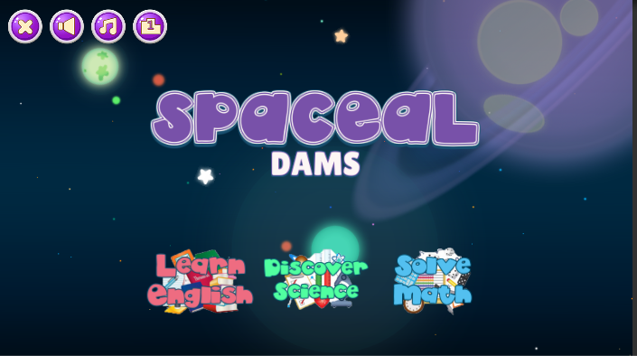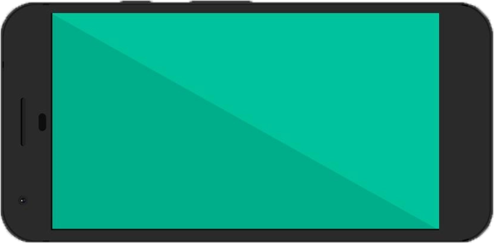

HOME

* Change appropriate subject names
* Show leadership icon on home screen

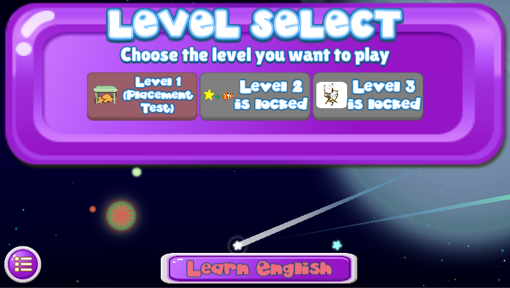

LEVEL SELECTION

* Change appropriate subject names
* Change text for level locking i.e. “Level 2 is locked”

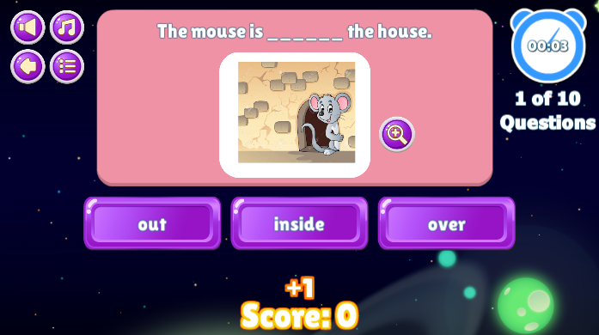

LEVEL 1 Multiple Choice

* 3-4 random choices
* Show current page of question i.e. “1 of 10 Questions”
* Score would be +1 and user “Score: 0”
* Prevent not to drag the questions in multiple choice
* Running time i.e. “00:03 but when already in hour shows 01:00:28 just in case for the UI”



LEVEL 1 Multiple Choice (continued)

* 3-4 random choices

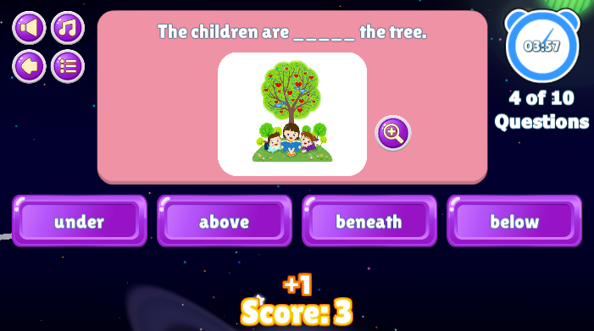



LEVEL 2 Drag answer to complete the question

* Randomize questions and answers
* Show current page of question i.e. “1 of 10 Questions”
* Score would be +1 and user “Score: 0”
* Prevent not to drag the questions in multiple choice
* Running time i.e. “00:05 but when already in hour shows 01:00:28 just in case for the UI”

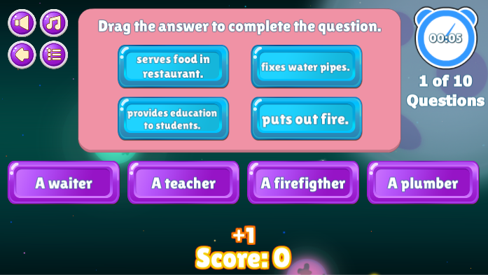



LEVEL 2 Drag answer to complete the question (continued)

* Draggable answers
* When the user doesn’t drop to the questions the answer goes back to its original position

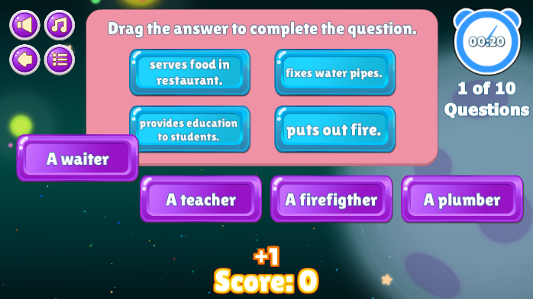



LEVEL 2 Drag answer to complete the question (continued)

* When the answer is correct does not +1 points to the user need to be correct all the questions for more challenging to the user
* Shows the question and user answer i.e. “serves food in restaurant. – A waiter”
* Properly arrange the answers when answers choices eliminated i.e. “Three questions left”
* Shows proper green/correct button

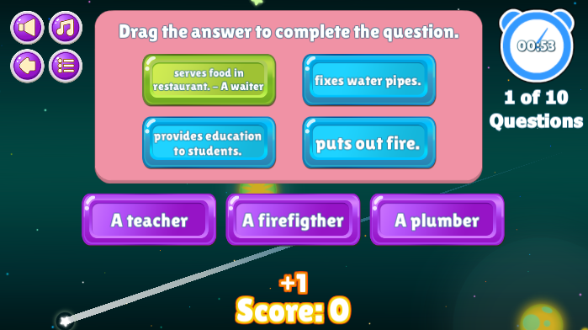



LEVEL 2 Drag answer to complete the question (continued)

* Shows the question and user answer i.e. “puts out fire. – A plumber”
* Properly arrange the answers when answers choices eliminated i.e. “Two questions left”
* Shows proper red/wrong button

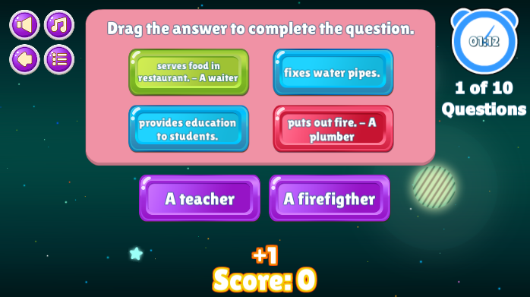

To do

* Scoring (computation)
* User management
* History (Name, Subject, Level, Time Spent, No. of attempts, Badges, Remarks)